Section 1: Communication Channels (Cables, Connectors, and Crimping)

1. List and explain the main differences between STP and UTP cables.

Answer: STP (Shielded Twisted Pair) cables have a shielding/protecting layer covering the twisted pair while, unshielded does not.

2. What are advantages and disadvantages of STP cables?

Answer: The shielding in STP helps to minimize electromagnetic interference (EMI) and crosstalk. It is also more secure than UTP.

3. Define Coaxial cable and mention two main uses in networking.

Answer: Coaxial cable is a type of electrical cable designed for efficient high-frequency signal transmission. An example can be a TV antenna or the cable that connects a satellite dish's receiver with the decoder.

It is mainly used in networking for TV antenna and providing internet.

4. What is the function of a BNC connector, and where is it typically used?

Answer: BNC connector is used to connect a coaxial cable with the intended device to provide a secure and reliable connection. It is typically used in a specific type of ethernet connection and connecting cameras with monitors and other devices.

5. Differentiate between RJ45 and RJ11 connectors in terms of: Number of pins Use in networking or telephony.

Answer: RJ45 has 8 pins that it uses to connect while RJ11 has 4 or 6 pins to connect. RJ45 is commonly used in Ethernet networking and RJ11 is usually used in telephone connections.

6. What is the maximum data transmission capacity and range of UTP Category 5e and 6 cables?

Answer: While both Category 5e and 6 UTP cables have a maximum transmission distance of 100m, the amount of data they transmit is different. That is Category 6 transmits data up to 10Gbps but Category 5e is limited to 1Gbps.

7. Name and describe the two main types of Fiber Optic cables.

Answer: The two main types of Fiber Optic cables are Single-Mode and Multimode.

Single-Mode cables carry data in long distances with high-bandwidth coverage. But Multimode is more suited for short distances with data throughput.

8. What is the difference between Single-mode and Multi-mode fiber?

Answer: Other than usage differences I mentioned above, Single-Mode and Multimode are different in their core radius.

Multimode has a large radius which allows multiple light modes to travel in it but after long distances, those rays start to degrade. And Single-Mode has a small radius which only allows a single light mode to pass in it which enables it to go very large distances without degradation and higher bandwidth but as mentioned it only transmits one mode of light.

9. Give two advantages of using fiber optic cables over copper cables.

Answer: Less susceptible to interference (EMI) and they can carry data for long distances with minimal signal loss. An example can be the cables that are laid in oceans for the internet.

10. Draw and label the color coding for T568A and T568B standards used in Ethernet cable crimping.

Answer:

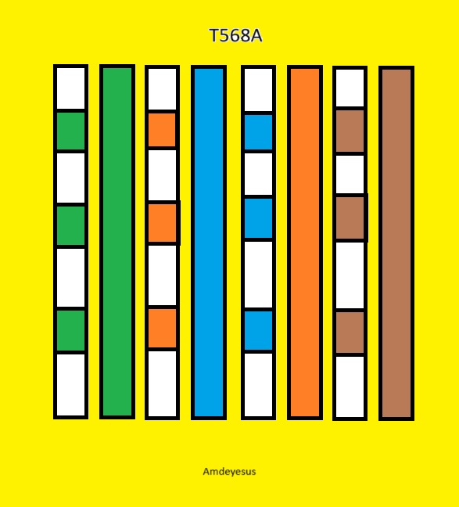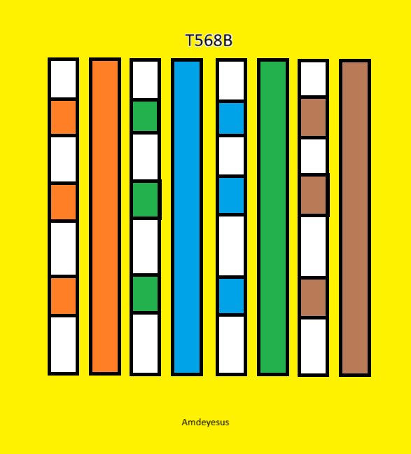

11. What is a Straight-through cable used for? List at least two examples.

Answer: A straight through cable is usually used to connect two different types of devices in a network. An example can be an Ethernet connection between a modem and a computer, connecting access points to switches etc.

12. What is a Crossover cable used for? Give at least one real-world use case.

Answer: A Crossover cable is usually used to connect two similar types of devices in a network. An example can be a connection between two computers although it is less common now.

13. Identify at least two tools used for creating or testing Ethernet cables.

Answer: To create the Ethernet cables, we could mention tools like cutters to uncover the plastic covering and crimping tool to attach the pins. For testing, tools like cable tester to check the integrity and cable tracer to- as the name says- trace the cables.

14. Fill in the blanks: A straight-through cable connects router to device. A crossover cable connects computer to computer.

15. Compare coaxial, twisted pair, and fiber optic cables in terms of: Cost, Speed & Susceptibility to interference.

Answer:

|  |  |  |  |
| --- | --- | --- | --- |
| Cables | Cost | Speed | Susceptibility to Interference |
| Coaxial | Lower than Fiber Optic | Higher than TP | Better than TP but still risky |
| Twisted Pair | Lowest Cost | Good but lowest | High Susceptibility |
| Fiber Optic | Highest Cost | Highest speed | Low Susceptibility |

Section 2: Communication Models

16. Define a communication model in computer networks.

Answer: A communication model explains how data is transmitted between two entities. It represents all the process and protocols the data has to go through to reach the receiver and to be sent by the sender.

17. What are the three basic types of data flow in communication? Give examples.

Answer: They are Simplex (e.g. A TV), Half-Duplex (e.g. Walkie-Talkie), and Full-Duplex (e.g. telephone)

18. Explain the difference between: Simplex Half-Duplex & Full-Duplex communication with examples.

Answer: Simplex transmits data only one way, which means data flows from the sender to receiver but not the other way around.

Half-Duplex transmits data in both directions but not at the same time. This means when the sender sends the data the receiver can only wait and receive and after receiving they can send their own data through the channel uninterrupted.

Full-Duplex transmits data in both directions at the same time. This means that every sender can receive while sending and every receiver can send while receiving through the same channels.

19. What is the importance of a protocol in a communication model?

Since protocols are a set of rules, procedures and conventions, they are absolutely crucial in a communication model. This is because they ensure the data integrity, the security of the medium, the authenticity of the sender and receiver etc. They are the reason and backbone for the communication models to be able to transmit data in a secure and orderly manner.

20. Briefly describe the basic elements of a communication system.

Answer: There are 5 basic elements that make up a communication system.

Sender – The one who sends the data/message.

Protocol – Are rules and procedures that control the communication.

Message – The data that is being transmitted.

Medium – The path or route the message will take to reach the receiver.

Receiver – The one who the message/data is intended for.

Section 3: OSI Model (In Detail)

21. Write down the seven layers of the OSI model in correct order (Top -> Bottom).

(Assuming 7 is bottom)

1 – Physical Layer

2 – Data Link Layer

3 – Network Layer

4 – Transport Layer

5 – Session Layer

6 – Presentation Layer

7 – Application Layer

22. Match the following OSI layers with their correct protocols:

a. Application – HTTP b. Transport – TCP c. Network – IP d. Data Link –

Ethernet e. Physical – Fiber Optic Cable (Options: HTTP, IP, Ethernet, TCP, and Fiber Optic

Cable)

23. What is the main function of the Transport Layer (Layer 4)? Include two protocols used in this layer.

Answer: It is the layer that provides error checking and other controls to ensure reliable data transfer.

24. At which layer does IP addressing occur? Explain its role.

Answer: It happens at the Network Layer. Assigning devices IP addresses helps the router to remember who is sending or receiving the data.

25. What is the Data Unit Name used at the following layers: Layer 4 (Transport) → segment Layer 3 (Network) → packet - Layer 2 (Data Link) → frame - Layer 1 (Physical) → bit.

26. Describe the difference between a router, a switch, and a hub, and match each to its corresponding OSI layer.

Answer: A Router is used to connect multiple networks together. Accordingly it is found in Network Layer.

A Switch also connects but unlike a Router, it connects multiple devices to a LAN. It is found in the Data Link Layer.

A Hub, although outdated, is used to connect multiple devices in a network and broadcast data to them. Even if there are similarities between a Hub and a Switch, a hub is located in the Physical Layer of the OSI model.

27. Explain what happens at each layer of the OSI model when you send a file from one computer to another.

Answer: Let’s assume I’m trying to send an email. In the Application Layer the protocols like SMTP generate the rules of engagement for the data I just clicked send on. Following this the Presentation Layer encodes the data to the necessary format. When completed the Session Layer takes over and creates a session or establishes connection for the transmission. After the session is created, the Transport Layer provides an end-to-end communication where the data is broken down to segments and get ready to be sent to the other end. Network Layer takes these segments and encapsulates them into packets while handling logical addressing (adds the source and destination IP address) and finding the best route to destination. Then Data Link Layer takes the packets and encapsulates them by adding mac addresses into frames. The frames are processed into the Physical Layer which is responsible for the actual transmission of raw bits over the network medium. It converts the frames into bits and transmits through a switch or router.

28. Why is the OSI model important in understanding how networks work?

Answer: It is important because it provides a standardized framework that describes how network communication occurs, simplifies network processes, helps in the design of networks and many more.

29. Give a real-life analogy (e.g., post office or package delivery) to explain the OSI model's layered process.

Answer:

Application Layer – I prepare the pen and paper and have what I want to write ready on a different paper.

Presentation Layer – I copy what I wrote in the other paper to the new one but it will have some type of encryption or cryptography.

Session Layer – I indicate that this won’t be the last letter and that he should wait for more.

Transport Layer – I put the letter in an envelope. If the letter contains too much I’ll break it to manageable pieces and put them in different envelopes labeled 1 of 4, 3 of 4, etc.

Network Layer – On each envelope, I will write the address of the receiver.

Data Link Layer – Here I will check that the envelopes are tightly sealed and I add delivery instructions for my post office like postage stamps.

Physical Layer – I give it to the postman or the mailbox.

30. BONUS: Describe how the OSI model compares to the TCP/IP model. Mention at least one similarity and one difference.

Answer: Both the OSI and TCP/IP models provide a layered framework for understanding network communication. However, they differ in their structure and purpose.

The OSI model is a theoretical 7-layer model with different functionalities for each layer, while the TCP/IP model is a more practical, 4 or 5-layer model that uses some OSI layers (e.g., its Application layer covers OSI's Application, Presentation, and Session layers).